**Name:**

**C++ Programming**

**Setting up a C++ Project in Visual Studio 2010**

**Lab Exercise 1.21.2020 Star Date: 73057.32**

1. From the Start Menu select Microsoft Visual Studio 2010.

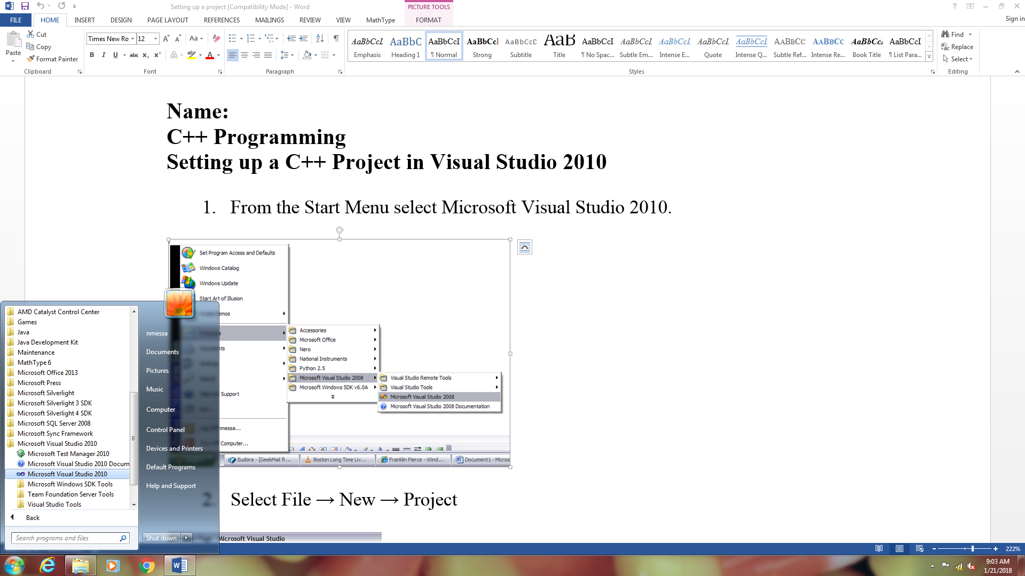

1. Select File → New → Project

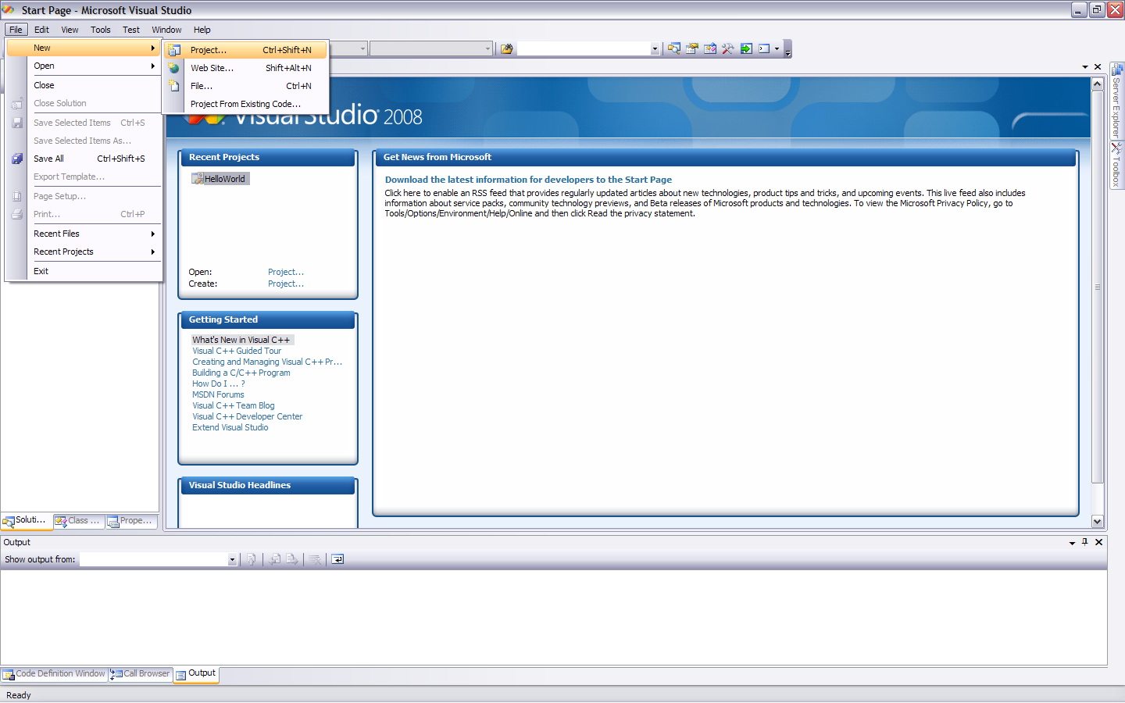

1. In the New Project Dialog, select an empty C++ project and name it *Hello*

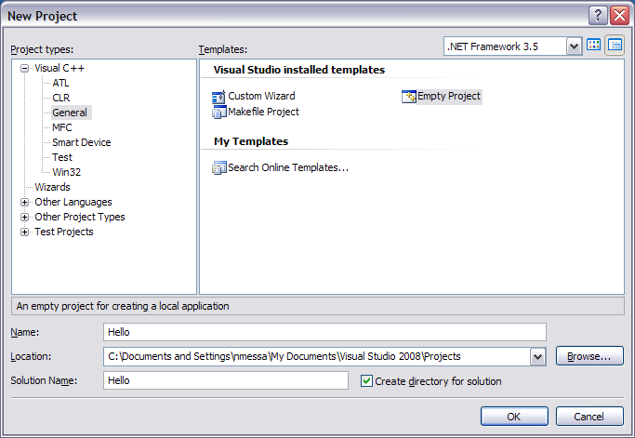

1. In the Solution Explorer you will see three empty folders; Header Files, Resource Files, and Source Files.

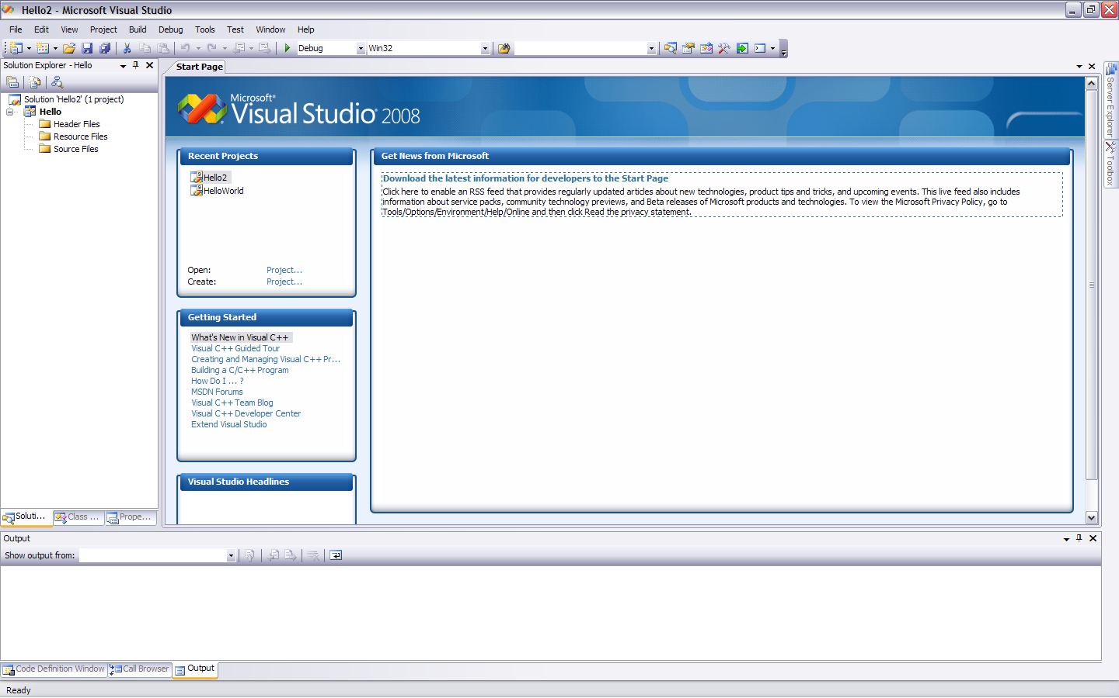

1. Add a C++ Source File by right-clicking on the project name Hello and selecting Add → New Item.

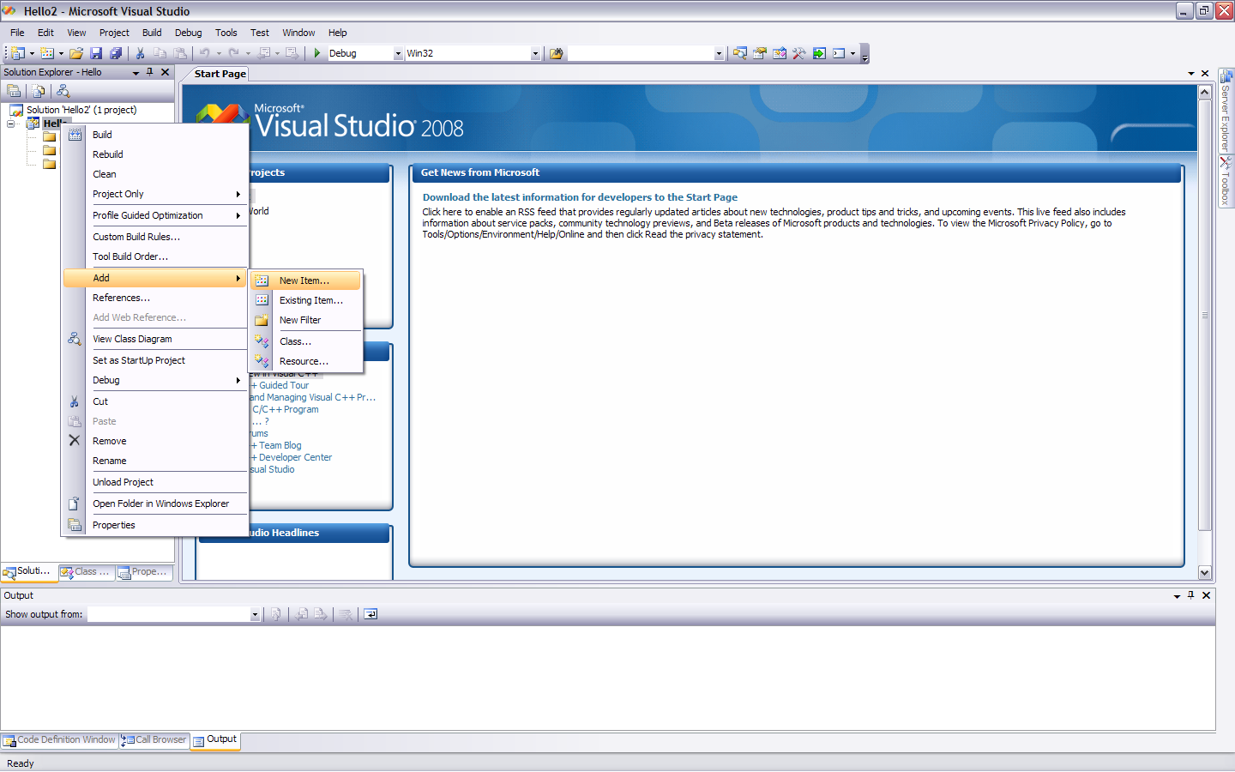

1. Select a C++ Source File from the Code group and name it *hello.cpp* and click the Add button and you will notice the file has been added to your Source Files folder.

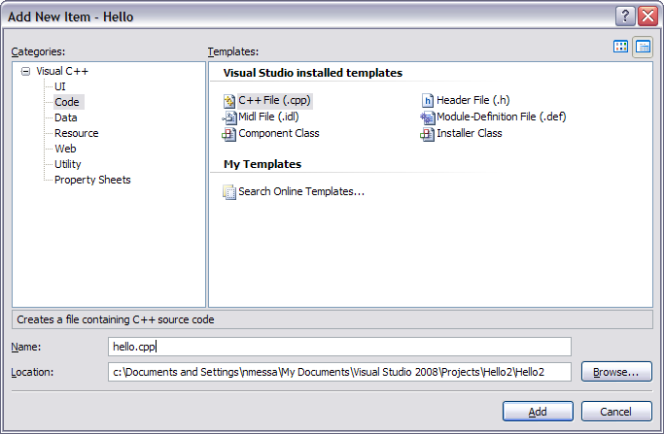

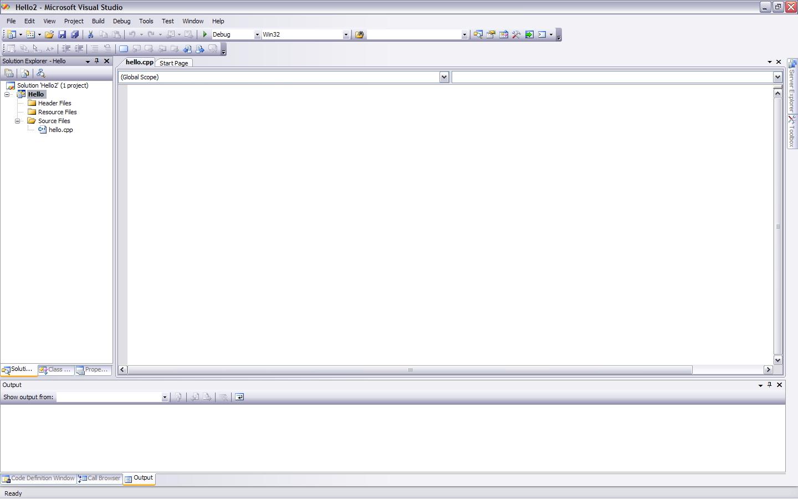

1. Now add the following code to the open window.

#include <iostream>

using namespace std;

int main()

{

cout << "Hello World" << endl;

return 0;

}

1. We will now run the program. In earlier versions of Visual C++ (2008 and earlier) when you selected Start Without Debugging, the output console stated open. In Visual C++ 2010 it closes right away which makes it difficult to admire your work. We could use system(“pause”) or getchar() to pause but a better method is to set your project properties. To do this, right-click on your project name in the solution explorer which will open the Project Properties window. You need to set the Configuration Properties\Linker\System\SubSystem to Console as such:

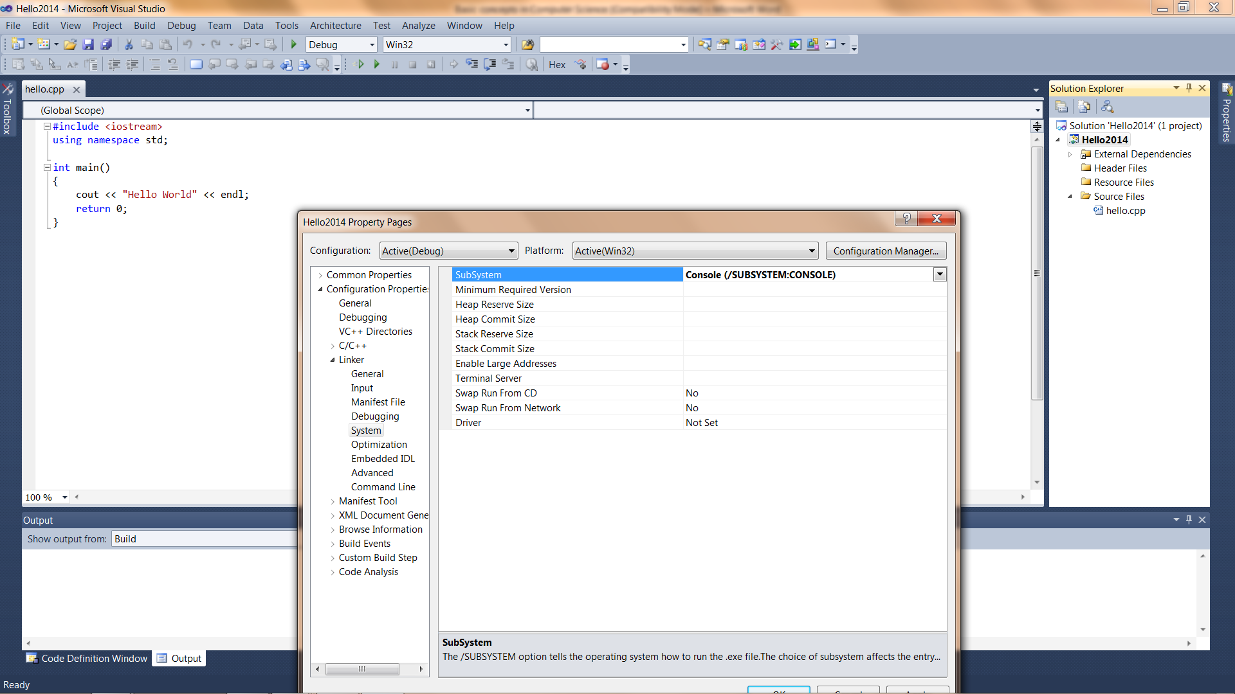

1. To run your program select Start without Debugging from the Debug menu.

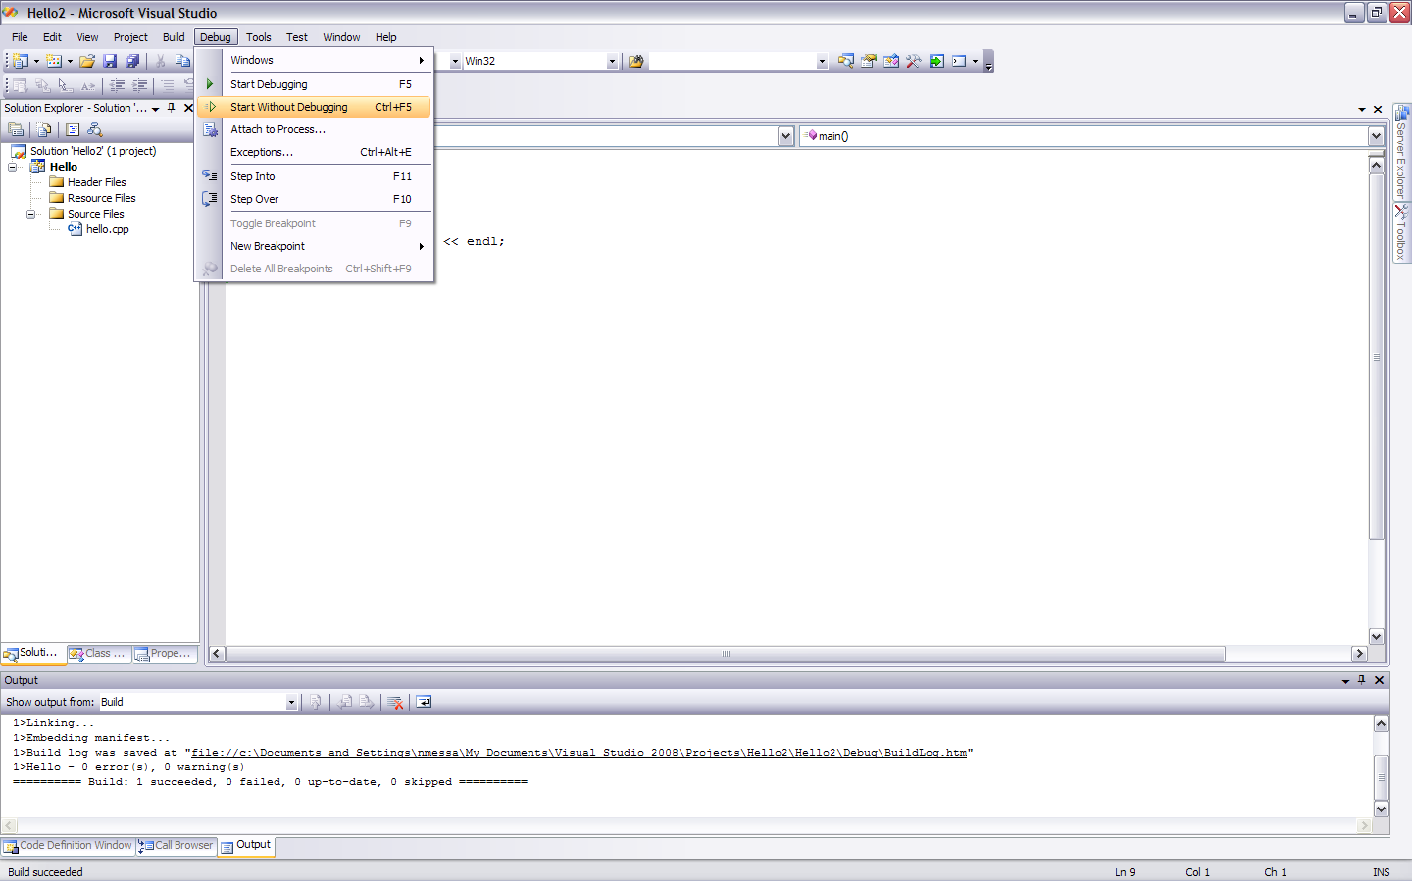

1. You should get the following output from your console.

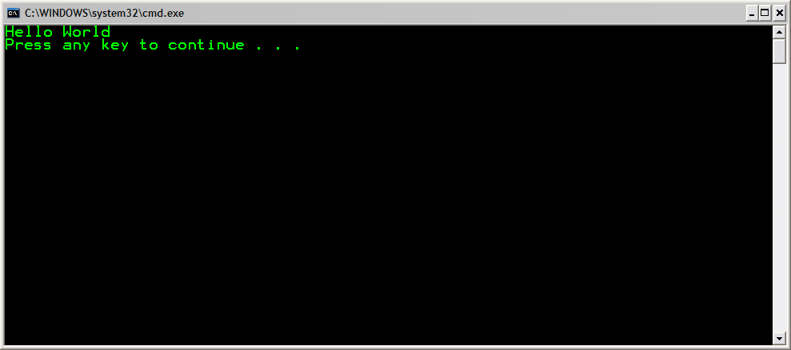

**Some problems to solve:**

1. Evaluate f(x) for the following functions for x = 3:



2. Write a program that prints out your name, address, city, state, and ZIP code in this format:

Mary A. Smith

13 Main Street

Exeter, NH 03833

3. Write a program that prints the number of seconds old you are. Hard code your age for this calculation and print the number of seconds to the nearest year.